Final Report
sbk002 and sodium fluorescein raw material
Dose formulation analysis methodology validation assay
Test facility
Name: | Suzhou Huace Biotechnology Co., Ltd.
Address: | Jiangsu Province, Kunshan City, New & Hi-tech Industrial Development Zone, Yuanfeng Road, 166
Telephone： | 0512-36801688
Sponsor
Name: | Chengdu Sibekang Biological Technology Co., Ltd.
Address: | Chengdu High-tech Zone (Western District) Xixin Avenue No. 17
Telephone： | 028-62532315
Study start and end dates: 2018-12-03 ~ 2019-01-21

signature page

Li Peng Date
Study Director

He Yan Date
QA

Statement of GLP Compliance

GLP regulations:
This assay was completed at Suzhou Huace Biological Technology Co., Ltd. (test facility), and all parts of the study adhere to the study protocol and the test facility's standard operating procedures (SOPs). This assay complies with the following medication non-clinical study Good Laboratory Practices (GLPs).
1. The non-clinical research quality management regulations (Order No. 34) issued by the China Food and Drug Administration (formerly CFDA) effective as of September 1, 2017.
No known events occurred during the study process that could affect data integrity.

Li Peng Date
Study Director

QA Statement

Study Director: Li Ping
Test article code: sbk002
Study Name: sbk002 and sodium fluorescein raw material dose formulations analytical methodology validation study
Study number: A2018030-FA01

According to the General Administration of Food and Drug Supervision and Administration's 'Good Laboratory Practice Regulations for Non-clinical Research of Drugs' (Order No. 34), effective from September 1, 2017, OECD Principles of Good Laboratory Practice (as revised in 1997) ENV/MC/CHEM(98)17, and the U.S. Food and Drug Administration's Good Laboratory Practice for Nonclinical Laboratory Studies (21CFR Part 58), an inspection will be conducted on experimental protocols and standard operating procedures (SOPs), and the inspection report will list the dates when the report is submitted to the study directors and institutional heads. Additionally, this statement confirms that the final report accurately reflects the original experimental data.
Inspection Contents | Inspection Date | Date of Report（SD/Test Facility Management）
study protocol | 2018-12-01 | 2018-12-01
Preparation of samples for analysis and testing | 2018-12-04 | 2018-12-04
Chromatography analysis | 2018-12-04 | 2018-12-04
Raw data | 2019-01-16 | 2019-01-16
Final Report | 2019-01-16 | 2019-01-16
In addition, the Quality Assurance Department conducts quarterly process inspections and annual institutional inspections in accordance with SOPs.

Special QA: He Yan
Signature: Date：

Table of Contents
Signature page 2
Statement of GLP Compliance 3
QA Statement 4
Table of Contents 5
ABSTRACT 7
1. General Information 10
1.1. Study Name and Number 10
1.2. Study Objective 10
1.3. Test Facility 10
1.4. Sponsor 10
1.5. Study Personnel Composition 10
1.6. Quality assurance personnel 11
1.7. Key Dates for Assay 11
1.8. Compliant regulations and technical guidelines 11
2. Study Materials and Methods 11
2.1. reference standard 11
2.2. Test Article 12
2.3. reference item 12
2.4. Major Instruments 13
2.5. Major Reagents 13
2.6. Related solution preparation 14
2.7. Analyzed Method 18
3. Methodology Validation 18
3.1 Methodology Validation Content List 18
4. data acquisition and analysis 20
5. Study protocol and amendments, deviations 20
6. Result 20
6.1. System Suitability 20
6.2. Stock Solution Comparison 20
6.3. Quality control 20
6.4. Specificity 20
6.5. Standard Curvelinear range 21
6.6. Carry-over 21
6.7. Lower Limit of Quantification 21
6.8. Accuracy and Precision 21
6.9. Dose formulations post-treatment stability 21
6.10. Dose formulations stability 21
7. Conclusion 22
8. Storage of Relevant Data 22
8.1. Archiving Time 22
8.2. Storage place and storage conditions 22
9. main references 23
10. Appendixes 23
Appendix One: Appendix Tables 25
Appendix 2: Appendix Figures 39
Appendix Three: Study protocol 48

ABSTRACT
Purpose: To validate the analytical method for determining the concentration of the test article in project A2018030, and to review the preparation method and stability of the dose formulations, ensuring the quality and accuracy of the test article and preparation, providing reliable scientific references for issues found in pre-clinical safety evaluations (e.g., toxicity and dose relationships).
Method: Use an ultra-high performance liquid chromatography (UHPLC) system to analyze the concentration and stability of the prepared dose formulations under the conditions of 220 nm wavelength. Test sbk002 and Clodifloxin (clo) using a UPLC® BEH C18 column with an appropriate washing degree. Validate the method's system suitability, stock solution comparison, quality control, specificity, linear range of the standard curve, carry-over, lower limit of quantification, accuracy, and precision. Validate the stability of dose formulations after disposal and the stability of dose formulations.
Result:
System Suitability (sbk002): The RSD of peak area is between 0.22 % and 0.50 %, the RSD of retention time is between 0.06 % and 0.08 %, and the tailing factor is between 1.17 and 1.39.
Stock solution comparison (sbk002): Ratio of peak area of Quality Control Sample QC and standard curve sample STD3 is between 96.71 % ~ 100.76 %.
Quality Control (sbk002): The accuracy of QC samples ranged from 96.57 % to 98.90 %, with a precision (RSD) of 0.48 % and 0.50 %.
Specificity: Blank solvent and blank vehicle specificity samples show no interference peaks at the retention times for sbk002/clo.
Standard Curve Linear Range (sbk002): The regression coefficient (R2) of the standard curve ranges from 0.9964 to 0.9993, and the accuracy for all concentrations in the standard curve ranges from 98.26% to 103.30%.
Carry-over (sbk002): No interference peaks at the retention time of sbk002 in blank solvent samples.
lower limit of quantification（sbk002）: signal-to-noise ratio S/N ranges between 83 ~ 242, accuracy ranges between 100.70 % ~ 102.06 %, precision RSD is 0.70 %.
accuracy and precision（sbk002）: accuracy ranges between 89.53 % ~ 104.95 %, intra-assay precision RSD ranges between 0.71 % ~ 5.54 %, inter-assay precision RSD is 4.25 %.
Post-dosing formulation stability (sbk002): The ratio of testing concentration of stability samples to initial concentration ranges from 96.68% to 99.88%, the ratio of testing concentration to labeled concentration ranges from 100.38% to 104.51%, and RSD is 2.10%.
Dose formulation stability (sbk002): Dose formulation room temperature covered for 2 h stability: The ratio of the concentrations of the stability sample to the initial concentration is between 96.19 % ~ 99.70 %, the ratio of the testing concentration to the labeled concentration is between 100.65 % ~ 102.21 %, RSD is 0.81 %; Dose formulation room temperature covered for 4 h stability: The ratio of the concentrations of the stability sample to the initial concentration is between 96.11 % ~ 98.45 %, the ratio of the testing concentration to the labeled concentration is between 100.87 % ~ 102.42 %, RSD is 0.87 %.
System suitability (clo): The RSD of peak area is between 0.25% ~ 0.48%, the RSD of retention time is between 0.00% ~ 0.08%, and the tailing factor is between 1.32 ~ 1.45.
Stock Solution Comparison (clo): Ratio of QC (quality control sample) to STD3 (standard curve sample) peak areas between 99.65% ~ 100.02%.
Quality Control (clo): The accuracy of QC samples ranged from 98.39 % to 99.61 %, with a precision (RSD) of 0.47 % and 0.12 %.
Standard Curve linear range (clo): The regression coefficient (R2) of the standard curve is between 0.9986 ~ 0.9998, and the accuracy of each concentration of the standard curve linearity is between 98.61 % ~ 102.84 %.
Carry-over (clo): Blank solvent samples at the retention time of clo show no interference peaks.
Lower Limit of Quantification (clo): The signal-to-noise ratio S/N is between 35 and 138, with accuracy between 98.96 % and 100.38 %, and precision RSD of 0.72 %.
Accuracy and precision (clo): Accuracy between 98.65% ~ 106.66%, intra-assay precision RSD between 1.23% ~ 1.98%, and inter-assay precision RSD at 2.59%.
Dose formulations post-processing stability (clo): The ratio of detected concentration to initial concentration for the stability samples ranged from 102.90 % to 105.99 %, and the ratio of detected concentration to nominal concentration ranged from 103.96 % to 104.56 %, with an RSD of 0.30 %.
Dose formulations stability (clo): Dose formulations room temperature light-shaded placement for 4-hour stability: The ratio of detected concentration to initial concentration for the stability samples ranged from 98.05 % to 101.78 %, and the ratio of detected concentration to nominal concentration ranged from 99.51 % to 100.99 %, with an RSD of 0.74 %.
Conclusion: The sbk002 and clo formulations analysis method established in this experiment exhibits good linearity within the concentration range of 5.0 ~ 15.0 μg/mL. System suitability, stock solution comparison, quality control, specificity, carry-over, lower limit of quantification, accuracy and precision meet the requirements for formulation analysis, making it suitable for the analysis and testing of sbk002 and clo formulations. The sbk002 formulations (concentration: 250.0 mg/mL) exhibit good stability under room temperature and light-protected conditions for 4 hours, and the formulations remain stable under the same conditions for 1 day after treatment; clo formulations (concentration: 250.0 mg/mL) also exhibit good stability under room temperature and light-protected conditions for 4 hours, and remain stable under the same conditions for 1 day after treatment.

General Information
  - Study Name and Number
Study Name: sbk002 and Clozifloxacin raw material formulations analysis method validation test;
Study Number: A2018030-FA01。
  - Study Objective
Verify the analytical methods for determining the test article concentration in project A2018030, and investigate the preparation method and stability of dose formulations to ensure the quality and preparation accuracy of the test article, providing reliable scientific references for issues identified in preclinical safety evaluations (e.g., toxicity and dose relationships).
  - Test facility
Name: Suzhou Huace Bio-tech Co., Ltd.；
Address: Jiangsu Province Kunshan City High-tech Zone Yuanfeng Road No.166；
Postal code: 215300;
Contact person: Xia Yuye;
Telephone：0512-36801688；
Fax: 0512-36802288；
Email: xiayuye@cti-cert.com。
  - Sponsor
Name：Chengdu Sibekang Biological Technology Co., Ltd.；
Address: Chengdu High-tech Zone (Western District) Xixin Avenue No.17；
Zip Code: 611731;
Contact：Mu Xia；
Telephone: 028-62532315；
Email: 779061281@qq.com。
  - Study Personnel composition
    - Study Director
Name: Li Ping；
Address: Jiangsu Province Kunshan City High-tech Zone Yuanfeng Road No.166；
Telephone：0512-36801688；
Fax: 0512-36802288；
Email: liping@cti-cert.com.
    - main personnel
Assay operation: Wei Fang Ding, Xiaoxue Wang, Mingmin Lu;
Test article management: Xiaochen Chen, Li Ran;
Preparation of test article: Shi Wenwen, Liu Lulu.
Data collation and statistical analysis: Li Peng, Wang Xiaoxiao, Zhao Qing.
  - Quality Assurance Personnel
Name: He Yan；
Telephone：0512-36801688；
Email: cti-btc-qa.list@cti-cert.com.
  - Key dates of the assay
Assay start date: 2018-12-04;
Assay end date: 2018-12-06.
  - Compliant regulations and technical guidelines
The regulations and technical guidance principles that this assay will adhere to include, but are not limited to:
Good Laboratory Practices (GLPs) for Non-Clinical Studies of Drugs (Former CFDA, September 2017);
《Non-clinical Safety Evaluation test article testing requirements Q&A》 (original CFDA, May 2014);
Pharmaceuticals Registration Management Measures (Original CFDA, October 2007);
The implementation of this assay, except for special instructions in the protocol, complied with the standard operating procedures of the testing facility (Standard Operating Procedures, SOPs).

Study Materials and Methods

  - reference product
Name: sbk002-D；
Characterization: off-white crystalline powder;
Specification: 2 g/bag;
Content: 99.6 %;
Batch number: 180704；
Expiry date: 2020-08-07;
Storage condition: 15 ~ 25 ℃, airtight, protected from light, dry;
Manufacturer: Chengdu Shibeikang Biotechnology Co., Ltd.;
Supplier：Chengdu Sibekang Biological Technology Co., Ltd.；
Protection measures: Operate according to the《Occupational Health Safety and Protection Manual》, wear appropriate personal protective equipment (PPE)；
Disposal of remaining reference products: Return to the sponsor.
  - Test Article
Name/Code：sbk002；
Facility code: W2018027；
Characterization: off-white crystalline powder;
Specification: 51.8 g/bag;
Content: 99.8%;
Batch number: 180802;
Expiry date: 2020-08-20 (tentative)；
Storage condition: 15 ~ 25 ℃, airtight, protected from light, dry;
Manufacturer: Chengdu Shibeikang Biotechnology Co., Ltd.;
Supplier：Chengdu Sibekang Biological Technology Co., Ltd.；
Protection measures: Operate according to the《Occupational Health Safety and Protection Manual》, wear appropriate personal protective equipment (PPE)；
Remaining test article handling: Return to the sponsor.
  - Reference item
Name/Code: Clopidogrel(Clo);
Characterization: White crystalline powder;
Specification: 38 g/bag;
Purity：99.75 %；
Batch number: 20171201;
Expiry date: 2019-11-30；
Storage condition: 15 ~ 25 ℃, airtight, protected from light, dry;
Manufacturer: Zhejiang Cheto Pharmaceutical Co., Ltd.;
Supplier：Chengdu Sibekang Biological Technology Co., Ltd.；
Protection measures: Operate according to the《Occupational Health Safety and Protection Manual》, wear appropriate personal protective equipment (PPE)；
Remaining test article handling: Return to the sponsor.
  - Major Instruments
Name | Model | Manufacturer
Ultra-High Performance Liquid Chromatograph | ACQUITY UPLC H-Class | Waters
Digital heating magnetic stirrer | MS-H280-Pro | Thermo Fisher
Magnetic stirrer | 84-1(Six) | Shanghai Meiyingpu Instrument & Meter Manufacturing Co., Ltd.
Refrigerated Centrifuge | 5418R | Eppendorf
Analytical balance | XSE105DU | Mettler-Toledo
Electronic balance | ML4002/02 | Mettler-Toledo
Electronic balance | ML203/02 | Mettler-Toledo
Electronic balance | MS204TS/02 | Mettler-Toledo
Ultrasonic cleaner | SB-5200DT | Ningbo Xinzhi Biotechnology Co., Ltd.
pure water instrument | ELIX® Advantage 5 | Millipore
Single-channel adjustable pipette | 2 - 20 μL、10 - 100 μL  20 - 200 μL、30 - 300 μL  100 - 1000 μL | Eppendorf
  - Major Reagents
Reagent Name | Reagent grade |  | Batch Number | Manufacturer
Sterilized Injection Water |  | / | M18080905-3 |  | Sichuan Kelun Pharmaceutical Co., Ltd.
Methanol |  | HPLC | 178511 |  | Fisher Scientific
Acetonitrile |  | HPLC | 184265 |  | Fisher Scientific
Trifluoroacetic acid / TFA |  | HPLC | I3980050 |  | CNW Technologies
Carboxymethyl cellulose sodium/CMC-Na |  | USP grade | F1719015 |  | Aladdin
pure water |  | / | / |  | Suzhou Huace Biotechnology Co., Ltd.
  - Related Solution Preparation
Each solution should be prepared and adjusted according to the required ratio and volume. Solutions without a specified expiry date (except for dose formulations) should be used immediately upon preparation. The preparation date of the first standard curve sample is defined as Day 1 (Day1/D1), and subsequent dates follow as Day n (Day n/Dn).
    - Preparation of the mobile phase
Aqueous phase (0.2% TFA aqueous solution): Measure 1000 μL of TFA, add it to 500 mL of sterile water for injection, mix well, and sonicate for degassing for 15 minutes. Store at room temperature, valid for 3 days.
Organic phase (Acetonitrile): Acetonitrile, sonicate to remove bubbles for 15 min, then ready for use. Store at room temperature, with a validity period of 1 month.
    - diluent preparation
Diluent 1 (Acetonitrile): Measure 400 mL of Acetonitrile. Store at room temperature. Valid for 1 month.
Diluent 2 (40% acetonitrile aqueous solution): Measure 400 mL of acetonitrile and add to 600 mL of sterilized injection water, mix well. Store at room temperature, valid for 1 month.
    - Standard Curve Sample Preparation
      - sbk002 Standard Curve Sample Preparation
Weigh 10.61 mg sbk002-D (content: 99.6%), dissolve it in a small amount of dissolution solvent and dilute to volume to 10 mL to prepare a standard curve stock solution of a certain concentration (concentration = weight × content/volume). Named: 181204-ST1-sbk.
Aspirate the above stock solution (181204-ST1-sbk) 946 μL, make up to volume with diluent 2 to 10 mL, obtain a standard curve working solution with a concentration of 100 μg/mL, named 181204-WS1-sbk.
Prepare standard curve samples using diluent 2.
Solution Name | aspirate solution | Aspirating Volume  （μL） | Dilute to volume volume  （mL） | Theoretical Concentration (μg/mL)
LR_STD1_sbk | 181204-WS1-sbk | 250 | 5 | 5.0
LR_STD2_sbk | 181204-WS1-sbk | 400 | 5 | 8.0
LR_STD3_sbk | 181204-WS1-sbk | 500 | 5 | 10.0
LR_STD4_sbk | 181204-WS1-sbk | 600 | 5 | 12.0
LR_STD5_sbk | 181204-WS1-sbk | 750 | 5 | 15.0
      - clo Standard Curve Sample Preparation
Weigh 10.37 mg clo (purity: 99.75%), dissolve and dilute to volume with Diluent 1 to 10 mL, to prepare a stock solution of a specified concentration (concentration = weighed amount × purity/volume). Named: 181204-ST1-clo.
Aspirate 967 μL from the above stock solution (181204-ST1-clo), dilute to volume with Diluent 2 to 10 mL, to obtain a standard working solution with a concentration of 100 μg/mL. Named: 181204-WS1-clo.
Prepare standard curve samples using diluent 2.
Solution Name | aspirate solution | Aspirating Volume  （μL） | Dilute to volume volume  （mL） | Nominal concentration  （μg/mL）
LR_STD1_clo | 181204-WS1-clo | 250 | 5 | 5.0
LR_STD2_clo | 181204-WS1-clo | 400 | 5 | 8.0
LR_STD3_clo | 181204-WS1-clo | 500 | 5 | 10.0
LR_STD4_clo | 181204-WS1-clo | 600 | 5 | 12.0
LR_STD5_clo | 181204-WS1-clo | 750 | 5 | 15.0
    - Quality Control Sample preparation
      - sbk002 Quality Control Sample preparation
Weigh 10.38 mg sbk002-D (content: 99.6%), dissolve and dilute to volume with Diluent 1 to 10 mL, to prepare a quality control stock solution of a specified concentration (concentration = weighed amount × content/volume). Named: 181204-ST2-sbk.
Aspirate the above stock solution (181204-ST2-sbk) 967 μL, dilute to volume with diluent to 10 mL, obtain a quality control working solution with a concentration of 100 μg/mL, named: 181204-WS2-sbk.
Prepare Quality Control Sample with Diluent 2.
Solution Name | aspirate solution | Aspirating Volume  （μL） | Dilute to volume volume  （mL） | Theoretical Concentration (μg/mL)
SST_QC_sbk | 181204-WS2-sbk | 500 | 5 | 10.0
LOQ_QCL_sbk_1 | 181204-WS2-sbk | 250 | 5 | 5.0
LOQ_QCL_sbk_2 | 181204-WS2-sbk | 250 | 5 | 5.0
LOQ_QCL_sbk_3 | 181204-WS2-sbk | 250 | 5 | 5.0
      - clo quality control sample preparation
Weigh 10.38 mg of clo (Purity: 99.75 %), dissolve with diluent 1 and dilute to volume up to 10 mL, preparing a quality control stock solution of a certain concentration (concentration = weighed amount × purity/volume). Named: 181204-ST2-clo.
Aspirate 966 μL of the above stock solution (181204-ST2-clo), dilute to 10 mL with diluent 2, to obtain a quality control working solution of 100 μg/mL, named: 181204-WS2-clo.
Prepare Quality Control Sample with Diluent 2.
Solution Name | aspirate solution | Aspirating Volume  （μL） | Dilute to volume volume  （mL） | Theoretical Concentration (μg/mL)
SST_QC_clo | 181204-WS2-clo | 500 | 5 | 10.0
LOQ_QCL_clo_1 | 181204-WS2-clo | 250 | 5 | 5.0
LOQ_QCL_clo_2 | 181204-WS2-clo | 250 | 5 | 5.0
LOQ_QCL_clo_3 | 181204-WS2-clo | 250 | 5 | 5.0
    - Preparation of vehicle (0.5% CMC-Na)
Preparation method: Accurately weigh a certain amount of CMC-Na powder, measure a certain volume of pure water with a measuring cylinder, transfer to a beaker, uniformly disperse the CMC-Na powder into the beaker, add a stirring bar, stir with a magnetic stirrer until completely dissolved, thus obtaining 0.5 % CMC-Na solution。
Preparation method: Accurately weigh 2.000 g of CMC-Na powder, measure 400 mL of pure water using a graduated cylinder, and transfer it to a beaker. Evenly disperse the CMC-Na powder into the beaker, add a stir bar, and stir with a magnetic stirrer until completely dissolved, resulting in a 0.5 % CMC-Na solution of 400 mL. Store at room temperature, effective within 7 days.
    - Specificity Sample Preparation
Prepare blank solvent specific sample using vehicle (0.5 % CMC-Na): aspirate 400 μL of vehicle, dilute to volume with diluent 1 to 10 mL, centrifuge (10000 r/min, 5 min, 20 ℃), aspirate 20 μL of the supernatant, dilute to volume with diluent 2 to 20 mL, obtaining blank vehicle specific sample, named: Select_V。
    - Preparation of dose formulations
Preparation method: Based on the concentration of the dose formulations and the required volume, calculate the amount of test article needed (sbk002 dose formulations concentration = amount taken × content/volume; clo dose formulations concentration = amount taken × purity/volume). In a room temperature environment protected from light, accurately weigh a specific amount of test article into a mortar, add an appropriate amount of 0.5% CMC-Na solution, grind thoroughly, then completely transfer to a volumetric container, adjust to volume with 0.5% CMC-Na to obtain the desired concentration of dose formulations.
Preparation method example: Take the preparation of 50 mL as an example.
Group | dose formulations  Labeled Concentration  （mg/mL） | Preparation Method
sbk002 Group | 250.0 | Accurately weigh 12.5251 g of sbk002 into a mortar, grind thoroughly with 0.5 % CMC-Na solution, then completely transfer to a volumetric container (50 mL). Dilute to the mark with 0.5 % CMC-Na to obtain sbk002 dose formulations of 250.0 mg/mL.
clo group | 250.0 | Accurately weigh 12.5313 g clo into a mortar, grind fully with 0.5 % CMC-Na solution, and completely transfer to a volumetric flask (50 mL), fill to the mark with 0.5 % CMC-Na, obtaining clo dose formulation of 250.0 mg/mL。
Preparation condition: room temperature, protected from excessive light;
Identification method: Dose formulations for the sbk002 group and clo group are labeled with green and blue tags, respectively, indicating the study number, name, concentration, quantity, preparation date, preparer, and finished product number;
Transported under the conditions: room temperature, and light shielding.
    - dose formulations sampling and processing methods
Sampling method: Prior to sampling, use a magnetic stirrer at a certain speed to stir for 15 min or longer. The speed should create a visible depression but not cause vortexing or large bubbles. Take 2 samples from the top, middle, and bottom layers of the test formulations for a total of 6 samples, and process them as per the table below.
Treatment method: Take the volume of dose formulations to be tested according to the table, dilute to volume with diluent 1 in the first step, centrifuge (10000 r/min, 5 min, 20 ℃), take the supernatant to perform the second step of dilution. After diluting to volume with diluent 2 in the second and third steps, analyze it on the machine.
Group | dose formulations  Labeled Concentration  (mg/mL) | First Step Dilution (S1) |  |  |  | Second dilution (S2) |  |  |  | Step 3 Dilution (S3) |  |  |  | Theoretical Concentration  (μg/mL)
Group | dose formulations  Labeled Concentration  (mg/mL) | Dose formulation (μL) |  | Dilute to volume Volume (mL) |  | S1  (μL) |  | Dilute to Volume Volume(mL) |  | S2  (μL) |  | Dilute to Volume Volume(mL)
sbk002 group (Group A) | 250.0 |  | 400 |  | 10 |  | 500 |  | 10 |  | 200 |  | 10 |  | 10.0
clo group  (Group B) | 250.0 |  | 400 |  | 10 |  | 500 |  | 10 |  | 200 |  | 10 |  | 10.0
Remaining sample disposal: After passing the test, return the remaining dose formulations to the test article management department for disposal as medication/chemical waste.
    - Preparation of other solutions
Wash (90% Methanol solution): Measure 900 mL Methanol and add to 100 mL sterilized injection water, sonicate to remove bubbles for 15 min, then ready for use. Store at room temperature, with a validity period of 1 month.
Purge Wash, Seal Wash (10% methanol aqueous solution): Measure 900 mL of sterile water for injection, add it to 100 mL of methanol, and sonicate for degassing for 15 minutes. Store at room temperature, valid for 7 days.
  - Analyzed Method
Ultra-High Performance Liquid Chromatograph: ACQUITY UPLC H-Class, Waters;
Chromatographic column: ACQUITY UPLC® BEH C18 1.7 μm 2.1 mm × 50 mm;
Detection wavelength: 220 nm;
Column temperature: 35 ℃；
Sample tray temperature: OFF;
Injection Volume: 1 μL;
flow rate: 0.3 mL/min；
Run time: 3 min (sbk002 run time); 1.5 min (clo run time)
Isocratic elution, Aqueous phase: Organic phase = 55: 45;
Wash: Sterilized Water for Injection: Methanol = 10 : 90;
Purge Wash, Seal Wash: Sterilized Injection Water : Methanol = 90 : 10.

Method validation

3.1 Methodology Validation Content List

Parameter | Assay Method | Acceptance Criteria
System Suitability | Select Quality Control Sample QC_X as the System Suitability sample, conduct 6 continuous repeated determinations before the analytical run to assess System Suitability, and statistically analyze the values of these 6 measurements. Named as: SST_QC_X. | The RSD of peak area and retention time ≤ 2 %;  Tail Factor (T): T ≤ 2.
Stock Solution Comparison | selection Quality Control Sample QC_X and Standard Curve STD3_X as Stock Solution Comparison samples. Named: SSC_QC_X and SSC_STD3_X. | The ratio of peak area is between 95 % and 105 %.
Specificity | Use Diluent 2 as the blank solvent sample, named: Select_S; Use the solvent preparation blank solvent specificity sample, named: Select_V; Use AP_A_1 and AP_B_1 as test article specificity samples, named: Select_sbk and Select_clo respectively. | Blank solvent and blank vehicle samples have no interference peaks at sbk002/clo retention time or the interference peak area is ≤ 10% of the lower limit of quantification peak area.
Standard Curve  linear range | Standard Curve linear range: 5.0 μg/mL ~ 15.0 μg/mL. Design the standard curve concentration of the corresponding compound as the x-axis, and the peak area of the corresponding compound as the y-axis to obtain the linear regression equation. Named: LR_STD1_X ~ LR_STD5_X. | Regression coefficient (R2) ≥ 0.99, the standard curve linearity for each concentration readback accuracy should be between 90% and 110%.
Carry-over | After running the upper limit of quantification sample (STD5_X), run 1 blank solvent sample (Diluent 2). Named: Carryover_X. | Blank solvent samples have no interference peaks or interfering peak areas at the retention time of sbk002/clo, or the interfering peak area is ≤10 % of the lower limit of quantification peak area.
Quality Control | Select QC samples QC_X as quality control samples, distribute evenly in the analytical run for repeated determination. Designated as: PCS_QC_X_n (n represents the nth determination in that analytical run). | Accuracy should be in the range of 95% ~ 105%, with a precision RSD ≤ 5% (when n ≥ 3, RSD is required).
lower limit of quantification | Parallel preparation of 3 QCL_X as the lower limit of quantification samples. Named: LOQ_QCL_X_1 ~ LOQ_QCL_X_3. | signal-to-noise ratio S/N ≥ 10, accuracy should be between 95 % ~ 105 %, RSD ≤ 5 %.
Accuracy and Precision | After processing the test formulations according to the sampling and processing methods of the dose formulations, the samples are analyzed. Different days will have three repeated analytical runs, using the standard curve to calculate the sample concentrations of each batch to determine the accuracy and precision of the method. Named: AP_A_1 ~ AP_A_6 and AP_B_1 ~ AP_B_6. | Each group's accuracy should be in the range of 85% ~ 115%, with intra- and inter-assay precision RSD ≤ 10%.
Stability after dose formulations disposal | Run the sbk002 group and clo group dose formulations prepared in the first analytical batch in the second analytical batch, with 3 samples for accuracy and precision (stored at room temperature, protected from light for 1 day). Named as: STA(Post)_A_1, STA(Post)_A_3, STA(Post)_A_5, STA(Post)_B_1 ~ STA(Post)_B_3, and STA(Post)_B_5. | The ratio of the testing concentration of stability samples to the labeled concentration for different groups is between 85 % ~ 115 %, and the ratio of the testing concentration to the initial concentration is between 90 % ~ 110 %, with an RSD of stability samples ≤ 10 %.
dose formulations  Stability | sbk002 dose formulations room temperature light-shielded stability: The D1 prepared sbk002 dose formulations were placed in room temperature light-shielded conditions for 2 h and 4 h, then sampled from the top, middle, and bottom layers, and treated according to the dose formulations treatment method before analysis. They are named: STA(Pre_2h)_A_1, STA(Pre_2h)_A_3, STA(Pre_2h)_A_5, STA(Pre_4h)_A_1, STA(Pre_4h)_A_3, and STA(Pre_4h)_A_5.  Room temperature light protection stability of clo dose formulations: Place the D1 prepared clo group dose formulations at room temperature with light protection for 4 hours, then take one sample each from the upper, middle, and lower layers of the dose formulations. Process according to the dose formulations treatment method and then analyze the sample. Named: STA(Pre_4h)_B_1, STA(Pre_4h)_B_3, and STA(Pre_4h)_B_5. | The ratio of the testing concentration of stability samples to the labeled concentration for different groups is between 85 % ~ 115 %, and the ratio of the testing concentration to the initial concentration is between 90 % ~ 110 %, with an RSD of stability samples ≤ 10 %.
Note: “X” indicates “sbk or clo”.

Data acquisition and analysis
All raw data within the facility are manually collected based on the study protocol and SOPs of Suzhou Huace Bioscience & Technology Co., Ltd., and collected by data acquisition systems. Manually collected data are transcribed into Excel tables for analysis and reporting. The electronic data collection systems for collecting and reporting are as follows:
System | Version | Use
Empower | 3 | UPLC testing concentration

Study protocol, amendments, and deviations
The study protocol is detailed in Appendix III. This assay did not produce any amendments or deviations to the study protocol.

Results

  - System Suitability
Assay results are in Appendix Table 1-1 and Table 1-2. System suitability (sbk002): peak area RSD between 0.22 % ~ 0.50 %, retention time RSD between 0.06 % ~ 0.08 %, tailing factor between 1.17 ~ 1.39; System suitability (clo): peak area RSD between 0.25 % ~ 0.48 %, retention time RSD between 0.00 % ~ 0.08 %, tailing factor between 1.32 ~ 1.45.
  - Stock Solution Comparison
Assay results are shown in Appendix Table 2-1 and Table 2-2. Stock Solution Comparison (sbk002): The ratio of the peak area of quality control sample QC to standard curve sample STD3 is between 96.71 % ~ 100.76 %; Stock Solution Comparison (clo): The ratio of the peak area of quality control sample QC to standard curve sample STD3 is between 99.65 % ~ 100.02 %.
  - Quality Control
The assay results are shown in Appendix 3-1 and 3-2. Quality Control (sbk002): The accuracy of the Quality Control sample QC ranges between 96.57% and 98.90%, with precision RSD of 0.48% and 0.50%; Quality Control (clo): The accuracy of the Quality Control sample QC ranges between 98.39% and 99.61%, with precision RSD of 0.47% and 0.12%.
  - Specificity
Assay results seen in Appendix Figure 1. Specificity: Placebo solution and placebo vehicle specificity samples in sbk002/clo retention time show no interference peaks.
  - Standard Curve Linear Range
Assay results are shown in Appendix 1 Table 4-1, Table 4-2 and Appendix 2 Figures 2-1, 2-2. Standard Curve Linear Range (sbk002): The regression coefficient (R2) of the standard curve is between 0.9964 and 0.9993, with accuracy for each concentration between 98.26 % and 103.30 %; Standard Curve Linear Range (clo): The regression coefficient (R2) of the standard curve is between 0.9986 and 0.9998, with accuracy for each concentration between 98.61 % and 102.84 %.
  - Carry-over
The assay results can be seen in Appendix II, Figures 3-1 and 3-2. System carry-over: The blank solvent samples have no interference peaks at the retention time of sbk002/clo.
  - lower limit of quantification
The test results are shown in Appendix 1, Table 5-1 and Table 5-2. Lower limit of quantification (sbk002): S/N ratio between 83 ~ 242, accuracy between 100.70 % ~ 102.06 %, precision RSD of 0.70 %; Lower limit of quantification (clo): S/N ratio between 35 ~ 138, accuracy between 98.96 % ~ 100.38 %, density RSD of 0.72 %。
  - Accuracy and Precision
Assay results are shown in Appendix Table 6-1, Table 6-2, and Table 7-1, Table 7-2. Accuracy and precision (sbk002): Accuracy is between 89.53 % and 104.95 %, intra-assay precision RSD is between 0.71 % and 5.54 %, inter-assay precision RSD is 4.25 %; Accuracy and precision (clo): Accuracy is between 98.65 % and 106.66 %, intra-assay precision RSD is between 1.23 % and 1.98 %, inter-assay precision RSD is 2.59 %。
  - Stability after dose formulations disposal
Assay results seen in Appendix 8-1 and 8-2. Post-dose formulation processing room temperature light-shaded placement for 1-day stability (sbk002): The ratio of detected concentration to initial concentration for the stability samples ranged from 96.68 % to 99.88 %, and the ratio of detected concentration to nominal concentration ranged from 100.38 % to 104.51 %, with an RSD of 2.10 %; Post-dose formulation processing room temperature light-shaded placement for 1-day stability (clo): The ratio of detected concentration to initial concentration for the stability samples ranged from 102.90 % to 105.99 %, and the ratio of detected concentration to nominal concentration ranged from 103.96 % to 104.56 %, with an RSD of 0.30 %.
  - Dose Formulations Stability
Assay results seen in Appendix 9-1 and 9-2.
Dose formulation stability (sbk002): Dose formulation room temperature covered for 2 h stability: The ratio of the concentrations of the stability sample to the initial concentration is between 96.19 % ~ 99.70 %, the ratio of the testing concentration to the labeled concentration is between 100.65 % ~ 102.21 %, RSD is 0.81 %; Dose formulation room temperature covered for 4 h stability: The ratio of the concentrations of the stability sample to the initial concentration is between 96.11 % ~ 98.45 %, the ratio of the testing concentration to the labeled concentration is between 100.87 % ~ 102.42 %, RSD is 0.87 %.
Dose formulations stability (clo): Dose formulations room temperature light-shaded placement for 4-hour stability: The ratio of detected concentration to initial concentration for the stability samples ranged from 98.05 % to 101.78 %, and the ratio of detected concentration to nominal concentration ranged from 99.51 % to 100.99 %, with an RSD of 0.74 %.

Conclusion
The assay established for sbk002 and clo dose formulations' analysis method showed good linearity in the concentration range of 5.0 ~ 15.0 μg/mL, meeting the requirements of system suitability, stock solution comparison, quality control, specificity, carry-over, lower limit of quantification, accuracy, and precision for formulation analysis. It can be used for the analysis and testing of sbk002 and clo dose formulations. Sbk002 dose formulations (concentration: 250.0 mg/mL) showed good stability at room temperature under light-shielded conditions for 4h, and retained good stability at room temperature under light-shielded conditions for 1 day after treatment. Clo dose formulations (concentration: 250.0 mg/mL) showed good stability at room temperature under light-shielded conditions for 4h, and retained good stability at room temperature under light-shielded conditions for 1 day after treatment.

Storage of relevant data
  - Archiving time
After the completion of the test, the study director shall transfer the test materials to the archives management department within 2 weeks after the completion of the study for filing. Paper materials shall be kept for at least five years after the drug is marketed, and electronic documents shall be preserved permanently.
  - Storage location and conditions
Storage location: Archives Management Department, Suzhou Huace Bioscience & Technology Co., Ltd.;
Storage condition: Routine;
Contact person: Wu Li；
Contact Telephone：0512-36801688。

Main references
[1] Whitmire ML, Bryan P, Henry TR, et al. Non Clinical Dose Formulation Analysis Method Validation and Sample Analysis [J]. AAPS J, 2010, 12 (4): 628-634.
[2] Gu Liqiang, Xin Yanfei, Gao Haiyan, Li Feng, et al. Discussion on issues related to the analysis of test articles in GLP institutions [J]. Toxicology Journal, 2012, 26(5): 388-390.
[3] Meng Xiang, Li Qian, Pan Xuan, Jiang Ting, et al. The significance and standardization requirements of test article testing in GLP research [J]. Toxicology Journal, 2011, 25(6): 471-473.
[4] Li Yaoting, Liang Jinqiang, Huang Zhiying. Detection and analysis of test articles in the drug safety evaluation study [J]. Drug Evaluation Research, 2014, 37(6): 541-543.
[5] Su Min, Wang Jingkun. Issues related to test articles affecting non-clinical safety evaluation of drugs[J]. China Pharmacy, 2015, 29(2): 141-146.

Appendixes
Appendix One: Appendix Tables
Table 1-1 System Suitability (sbk002)
Table 1-2 System Suitability（clo）
Table 2-1 Stock Solution Comparison (sbk002)
Section 2-2 Stock Solution Comparison (clo)
Table 3-1 Quality Control (sbk002)
Table 3-2 Quality Control (clo)
Table 4-1 Standard Curve linear range (sbk002)
Table 4-2 Standard Curve linear range (clo)
Table 5-1 Lower limit of quantification (sbk002)
Table 5-2 Lower Limit of Quantification (clo)
Summary 6-1 Accuracy (sbk002)
Summary 6-2 Accuracy (clo)
Summary 7-1 Precision (sbk002)
Table 7-2 Precision (clo)
Table 8-1 Dose formulation stability after disposal (sbk002)
Summary 8-2 Dose Formulations Post-treatment Stability (clo)
Table 9-1 Dose formulation stability (sbk002)
Table 9-2 Dose formulation stability (clo)
Appendix 2: Figures
Figure 1 Specificity
Figure 2-1 Standard Curve Linear Range (sbk002)
Figure 2-2 Standard Curve Linear Range (clo)
Figure 3-1 Carry-over (sbk002)
Figure 3-2 Carry-over (clo)
Appendix 3: Study Protocol

Appendix One: Appendix Tables
Study Name: sbk002 and sodium fluorescein raw material dose formulations analytical methodology validation study
Study Number: A2018030-FA01 Table 1-1 System Suitability (sbk002)
Date | Name | Peak Area (Area) | Retention Time  (min) | Tail Factor (T)
2018-12-04 | SST_QC_sbk | 111433 | 1.431 | 1.37
2018-12-04 | SST_QC_sbk | 112185 | 1.434 | 1.38
2018-12-04 | SST_QC_sbk | 111546 | 1.432 | 1.36
2018-12-04 | SST_QC_sbk | 111657 | 1.432 | 1.37
2018-12-04 | SST_QC_sbk | 110548 | 1.433 | 1.37
2018-12-04 | SST_QC_sbk | 111020 | 1.431 | 1.37
2018-12-04 | Mean | 111398 | 1.432
2018-12-04 | SD | 561 | 0.001
2018-12-04 | RSD(%) | 0.50 | 0.08
2018-12-05 | SST_QC_sbk | 109758 | 1.439 | 1.37
2018-12-05 | SST_QC_sbk | 109443 | 1.439 | 1.39
2018-12-05 | SST_QC_sbk | 109119 | 1.442 | 1.37
2018-12-05 | SST_QC_sbk | 109283 | 1.440 | 1.39
2018-12-05 | SST_QC_sbk | 109840 | 1.439 | 1.39
2018-12-05 | SST_QC_sbk | 108471 | 1.440 | 1.37
2018-12-05 | Mean | 109319 | 1.440
2018-12-05 | SD | 498 | 0.001
2018-12-05 | RSD(%) | 0.46 | 0.08
2018-12-06 | SST_QC_sbk | 110170 | 1.493 | 1.17
2018-12-06 | SST_QC_sbk | 110348 | 1.493 | 1.17
2018-12-06 | SST_QC_sbk | 110465 | 1.493 | 1.17
2018-12-06 | SST_QC_sbk | 110746 | 1.493 | 1.17
2018-12-06 | SST_QC_sbk | 110642 | 1.495 | 1.18
2018-12-06 | SST_QC_sbk | 110169 | 1.494 | 1.17
2018-12-06 | Mean | 110423 | 1.494
2018-12-06 | SD | 240 | 0.001
2018-12-06 | RSD(%) | 0.22 | 0.06

Table 1-2 System Suitability (clo)
Date | Name | Peak Area (Area) | Retention Time  (min) | Tailing factor (T)
2018-12-04 | SST_QC_clo | 55760 | 0.764 | 1.44
2018-12-04 | SST_QC_clo | 55863 | 0.764 | 1.43
2018-12-04 | SST_QC_clo | 55592 | 0.765 | 1.44
2018-12-04 | SST_QC_clo | 55550 | 0.763 | 1.43
2018-12-04 | SST_QC_clo | 55807 | 0.764 | 1.44
2018-12-04 | SST_QC_clo | 55329 | 0.764 | 1.43
2018-12-04 | Mean | 55650 | 0.764
2018-12-04 | SD | 199 | 0.001
2018-12-04 | RSD(%) | 0.36 | 0.08
2018-12-05 | SST_QC_clo | 55286 | 0.764 | 1.44
2018-12-05 | SST_QC_clo | 55693 | 0.764 | 1.45
2018-12-05 | SST_QC_clo | 55034 | 0.764 | 1.45
2018-12-05 | SST_QC_clo | 55411 | 0.764 | 1.44
2018-12-05 | SST_QC_clo | 54978 | 0.764 | 1.44
2018-12-05 | SST_QC_clo | 55150 | 0.764 | 1.44
2018-12-05 | Mean | 55259 | 0.764
2018-12-05 | SD | 266 | 0.000
2018-12-05 | RSD(%) | 0.48 | 0.00
2018-12-06 | SST_QC_clo | 55062 | 0.797 | 1.32
2018-12-06 | SST_QC_clo | 55093 | 0.796 | 1.32
2018-12-06 | SST_QC_clo | 54780 | 0.796 | 1.33
2018-12-06 | SST_QC_clo | 54808 | 0.797 | 1.32
2018-12-06 | SST_QC_clo | 54837 | 0.797 | 1.33
2018-12-06 | SST_QC_clo | 54859 | 0.797 | 1.32
2018-12-06 | Mean | 54907 | 0.797
2018-12-06 | SD | 135 | 0.001
2018-12-06 | RSD(%) | 0.25 | 0.06

Table 2-1 Comparison of Stock Solution (sbk002)
Date | SSC_QC_sbk Peak Area (A1) | SSC_STD3_sbk Peak Area (A2) | A1/A2(%)
2018-12-04 | 112215 | 111369 | 100.76
2018-12-05 | 108072 | 111750 | 96.71
2018-12-06 | 110053 | 111240 | 98.93

Table 2-2 Stock Solution Comparison (clo)
Date | SSC_QC_clo Peak Area(A1) | SSC_STD3_clo Peak Area(A2) | A1/A2(%)
2018-12-04 | 55775 | 55763 | 100.02
2018-12-05 | 54945 | 55137 | 99.65
2018-12-06 | 54765 | 54952 | 99.66

Table 3-1 Quality Control (sbk002)
Date | Name | Theoretical Concentration (μg/mL) | Measured Concentration (μg/mL) | accuracy (%)
2018-12-04 | PCS_QC_sbk_1 | 10.0 | 9.890 | 98.90
2018-12-04 | PCS_QC_sbk_2 | 10.0 | 9.830 | 98.30
2018-12-04 | PCS_QC_sbk_3 | 10.0 | 9.773 | 97.73
2018-12-04 | PCS_QC_sbk_4 | 10.0 | 9.776 | 97.76
2018-12-04 | PCS_QC_sbk_5 | 10.0 | 9.845 | 98.45
2018-12-04 | PCS_QC_sbk_6 | 10.0 | 9.784 | 97.84
2018-12-04 | Mean |  | 9.816
2018-12-04 | SD |  | 0.047
2018-12-04 | RSD(%) |  | 0.48
2018-12-05 | PCS_QC_sbk_1 | 10.0 | 9.699 | 96.99
2018-12-05 | PCS_QC_sbk_2 | 10.0 | 9.657 | 96.57
2018-12-05 | PCS_QC_sbk_3 | 10.0 | 9.753 | 97.53
2018-12-05 | Mean |  | 9.703
2018-12-05 | SD |  | 0.048
2018-12-05 | RSD(%) |  | 0.50
2018-12-06 | PCS_QC_sbk_1 | 10.0 | 9.840 | 98.40
2018-12-06 | PCS_QC_sbk_2 | 10.0 | 9.824 | 98.24
Table 3-2 Quality Control (clo)
Date | Name | Theoretical Concentration (μg/mL) | Measured Concentration (μg/mL) | accuracy (%)
2018-12-04 | PCS_QC_clo_1 | 10.0 | 9.870 | 98.70
2018-12-04 | PCS_QC_clo_2 | 10.0 | 9.866 | 98.66
2018-12-04 | PCS_QC_clo_3 | 10.0 | 9.867 | 98.67
2018-12-04 | PCS_QC_clo_4 | 10.0 | 9.961 | 99.61
2018-12-04 | Mean |  | 9.891
2018-12-04 | SD |  | 0.047
2018-12-04 | RSD(%) |  | 0.47
2018-12-05 | PCS_QC_clo_1 | 10.0 | 9.899 | 98.99
2018-12-05 | PCS_QC_clo_2 | 10.0 | 9.920 | 99.20
2018-12-05 | PCS_QC_clo_3 | 10.0 | 9.901 | 99.01
2018-12-05 | Mean |  | 9.907
2018-12-05 | SD |  | 0.012
2018-12-05 | RSD(%) |  | 0.12
2018-12-06 | PCS_QC_clo_1 | 10.0 | 9.839 | 98.39
2018-12-06 | PCS_QC_clo_2 | 10.0 | 9.842 | 98.42

Table 4-1 Standard Curve linear range (sbk002)
Date | Name | Theoretical Concentration (μg/mL) | Measured Concentration (μg/mL) | accuracy （%） | R²
2018-12-04 | LR_STD1_sbk | 5.0 | 5.047 | 100.94 | 0.9993
2018-12-04 | LR_STD2_sbk | 8.0 | 8.066 | 100.83 | 0.9993
2018-12-04 | LR_STD3_sbk | 10.0 | 9.838 | 98.38 | 0.9993
2018-12-04 | LR_STD4_sbk | 12.0 | 11.957 | 99.64 | 0.9993
2018-12-04 | LR_STD5_sbk | 15.0 | 15.091 | 100.61 | 0.9993
2018-12-04 | Linear equation | Y = 1.15e+004 X - 1.87e+003
2018-12-05 | LR_STD1_sbk | 5.0 | 4.943 | 98.86 | 0.9976
2018-12-05 | LR_STD2_sbk | 8.0 | 8.264 | 103.30 | 0.9976
2018-12-05 | LR_STD3_sbk | 10.0 | 9.841 | 98.41 | 0.9976
2018-12-05 | LR_STD4_sbk | 12.0 | 11.837 | 98.64 | 0.9976
2018-12-05 | LR_STD5_sbk | 15.0 | 15.114 | 100.76 | 0.9976
2018-12-05 | Linear equation | Y = 1.13e+004 X - 3.32e+003
2018-12-06 | LR_STD1_sbk | 5.0 | 5.042 | 100.84 | 0.9964
2018-12-06 | LR_STD2_sbk | 8.0 | 7.861 | 98.26 | 0.9964
2018-12-06 | LR_STD3_sbk | 10.0 | 9.882 | 98.82 | 0.9964
2018-12-06 | LR_STD4_sbk | 12.0 | 12.381 | 103.18 | 0.9964
2018-12-06 | LR_STD5_sbk | 15.0 | 14.834 | 98.89 | 0.9964
2018-12-06 | Linear equation | Y = 1.15e+004 X - 3.11e+003
Table 4-2 Standard Curve linear range (clo)
Date | Name | Theoretical Concentration (μg/mL) | Measured Concentration (μg/mL) | accuracy （%） | R²
2018-12-04 | LR_STD1_clo | 5.0 | 5.142 | 102.84 | 0.9986
2018-12-04 | LR_STD2_clo | 8.0 | 7.889 | 98.61 | 0.9986
2018-12-04 | LR_STD3_clo | 10.0 | 9.958 | 99.58 | 0.9986
2018-12-04 | LR_STD4_clo | 12.0 | 11.854 | 98.78 | 0.9986
2018-12-04 | LR_STD5_clo | 15.0 | 15.156 | 101.04 | 0.9986
2018-12-04 | Linear equation | Y = 5.68e+003 X - 2.11e+002
2018-12-05 | LR_STD1_clo | 5.0 | 5.027 | 100.54 | 0.9998
2018-12-05 | LR_STD2_clo | 8.0 | 7.944 | 99.30 | 0.9998
2018-12-05 | LR_STD3_clo | 10.0 | 9.984 | 99.84 | 0.9998
2018-12-05 | LR_STD4_clo | 12.0 | 12.069 | 100.58 | 0.9998
2018-12-05 | LR_STD5_clo | 15.0 | 14.977 | 99.85 | 0.9998
2018-12-05 | Linear equation | Y = 5.59e+003 X - 3.99e+002
2018-12-06 | LR_STD1_clo | 5.0 | 5.075 | 101.50 | 0.9996
2018-12-06 | LR_STD2_clo | 8.0 | 7.960 | 99.50 | 0.9996
2018-12-06 | LR_STD3_clo | 10.0 | 9.878 | 98.78 | 0.9996
2018-12-06 | LR_STD4_clo | 12.0 | 12.047 | 100.39 | 0.9996
2018-12-06 | LR_STD5_clo | 15.0 | 15.040 | 100.27 | 0.9996
2018-12-06 | Linear equation | Y = 5.58e+003 X - 1.81e+002
Table 5-1 Lower limit of quantification (sbk002)
Date | Name | Theoretical Concentration (μg/mL) | Measured Concentration (μg/mL) | Accuracy (%） | S/N
2018-12-04 | LOQ_QCL_sbk_1 | 5.0 | 5.035 | 100.70 | 242
2018-12-04 | LOQ_QCL_sbk_2 | 5.0 | 5.103 | 102.06 | 92
2018-12-04 | LOQ_QCL_sbk_3 | 5.0 | 5.086 | 101.72 | 83
2018-12-04 | Mean |  | 5.075
2018-12-04 | SD |  | 0.035
2018-12-04 | RSD(%) |  | 0.70

Table 5-2 Lower Limit of Quantification (clo)
Date | Name | Theoretical Concentration (μg/mL) | Measured Concentration (μg/mL) | Accuracy (%） | S/N
2018-12-04 | LOQ_QCL_clo_1 | 5.0 | 4.977 | 99.54 | 138
2018-12-04 | LOQ_QCL_clo_2 | 5.0 | 5.019 | 100.38 | 35
2018-12-04 | LOQ_QCL_clo_3 | 5.0 | 4.948 | 98.96 | 99
2018-12-04 | Mean |  | 4.981
2018-12-04 | SD |  | 0.036
2018-12-04 | RSD(%) |  | 0.72
Table 6-1 Accuracy（sbk002）
Date | Name | Dose formulations labeled concentration (mg/mL) | dilution factor | Theoretical Concentration (μg/mL) | Measured Concentration (μg/mL) | Testing concentration (mg/mL） | Accuracy (%）
2018-12-04 | AP_A_1 | 250.0 | 25000 | 10.0 | 10.252 | 256.300 | 102.52
2018-12-04 | AP_A_2 | 250.0 | 25000 | 10.0 | 10.240 | 256.000 | 102.40
2018-12-04 | AP_A_3 | 250.0 | 25000 | 10.0 | 10.495 | 262.375 | 104.95
2018-12-04 | AP_A_4 | 250.0 | 25000 | 10.0 | 10.401 | 260.025 | 104.01
2018-12-04 | AP_A_5 | 250.0 | 25000 | 10.0 | 10.464 | 261.600 | 104.64
2018-12-04 | AP_A_6 | 250.0 | 25000 | 10.0 | 10.418 | 260.450 | 104.18
2018-12-05 | AP_A_1 | 250.0 | 25000 | 10.0 | 9.629 | 240.725 | 96.29
2018-12-05 | AP_A_2 | 250.0 | 25000 | 10.0 | 8.953 | 223.825 | 89.53
2018-12-05 | AP_A_3 | 250.0 | 25000 | 10.0 | 9.585 | 239.625 | 95.85
2018-12-05 | AP_A_4 | 250.0 | 25000 | 10.0 | 9.351 | 233.775 | 93.51
2018-12-05 | AP_A_5 | 250.0 | 25000 | 10.0 | 10.353 | 258.825 | 103.53
2018-12-05 | AP_A_6 | 250.0 | 25000 | 10.0 | 10.261 | 256.525 | 102.61
2018-12-06 | AP_A_1 | 250.0 | 25000 | 10.0 | 9.772 | 244.300 | 97.72
2018-12-06 | AP_A_2 | 250.0 | 25000 | 10.0 | 9.971 | 249.275 | 99.71
2018-12-06 | AP_A_3 | 250.0 | 25000 | 10.0 | 9.839 | 245.975 | 98.39
2018-12-06 | AP_A_4 | 250.0 | 25000 | 10.0 | 9.819 | 245.475 | 98.19
2018-12-06 | AP_A_5 | 250.0 | 25000 | 10.0 | 9.906 | 247.650 | 99.06
2018-12-06 | AP_A_6 | 250.0 | 25000 | 10.0 | 9.878 | 246.950 | 98.78
Note: Accuracy = Detected concentration / dosing formulation labeled concentration, Detected concentration = Measured concentration × Dilution factor. Table 6-2 Accuracy (clo)
Date | Name | Dose formulations labeled concentration (mg/mL) | dilution factor | Theoretical Concentration (μg/mL) | Measured Concentration (μg/mL) | Testing concentration (mg/mL） | Accuracy (%）
2018-12-04 | AP_B_1 | 250.0 | 25000 | 10.0 | 10.149 | 253.725 | 101.49
2018-12-04 | AP_B_2 | 250.0 | 25000 | 10.0 | 10.147 | 253.675 | 101.47
2018-12-04 | AP_B_3 | 250.0 | 25000 | 10.0 | 9.957 | 248.925 | 99.57
2018-12-04 | AP_B_4 | 250.0 | 25000 | 10.0 | 10.063 | 251.575 | 100.63
2018-12-04 | AP_B_5 | 250.0 | 25000 | 10.0 | 9.865 | 246.625 | 98.65
2018-12-04 | AP_B_6 | 250.0 | 25000 | 10.0 | 9.889 | 247.225 | 98.89
2018-12-05 | AP_B_1 | 250.0 | 25000 | 10.0 | 10.560 | 264.000 | 105.60
2018-12-05 | AP_B_2 | 250.0 | 25000 | 10.0 | 10.600 | 265.000 | 106.00
2018-12-05 | AP_B_3 | 250.0 | 25000 | 10.0 | 10.581 | 264.525 | 105.81
2018-12-05 | AP_B_4 | 250.0 | 25000 | 10.0 | 10.638 | 265.950 | 106.38
2018-12-05 | AP_B_5 | 250.0 | 25000 | 10.0 | 10.364 | 259.100 | 103.64
2018-12-05 | AP_B_6 | 250.0 | 25000 | 10.0 | 10.335 | 258.375 | 103.35
2018-12-06 | AP_B_1 | 250.0 | 25000 | 10.0 | 10.348 | 258.700 | 103.48
2018-12-06 | AP_B_2 | 250.0 | 25000 | 10.0 | 10.666 | 266.650 | 106.66
2018-12-06 | AP_B_3 | 250.0 | 25000 | 10.0 | 10.404 | 260.100 | 104.04
2018-12-06 | AP_B_4 | 250.0 | 25000 | 10.0 | 10.387 | 259.675 | 103.87
2018-12-06 | AP_B_5 | 250.0 | 25000 | 10.0 | 10.060 | 251.500 | 100.60
2018-12-06 | AP_B_6 | 250.0 | 25000 | 10.0 | 10.555 | 263.875 | 105.55
Note: Accuracy = Testing concentration / Label concentration of dose formulation, Testing concentration = Measured concentration × Dilution factor. Table 7-1 Precision (sbk002)
dose formulations  labeled concentration（mg/mL） | Name | Measured Concentration (μg/mL) |  |  | Inter-assay Precision
dose formulations  labeled concentration（mg/mL） | Name | 2018-12-04 | 2018-12-05 | 2018-12-06 | Mean （μg/mL） | SD （μg/mL） | RSD (%)
250.0 | AP_A_1 | 10.252 | 9.629 | 9.772 | 9.977 | 0.424 | 4.25
250.0 | AP_A_2 | 10.240 | 8.953 | 9.971 | 9.977 | 0.424 | 4.25
250.0 | AP_A_3 | 10.495 | 9.585 | 9.839 | 9.977 | 0.424 | 4.25
250.0 | AP_A_4 | 10.401 | 9.351 | 9.819 | 9.977 | 0.424 | 4.25
250.0 | AP_A_5 | 10.464 | 10.353 | 9.906 | 9.977 | 0.424 | 4.25
250.0 | AP_A_6 | 10.418 | 10.261 | 9.878 | 9.977 | 0.424 | 4.25
250.0 | Mean | 10.378 | 9.689 | 9.864
250.0 | SD | 0.108 | 0.536 | 0.070
250.0 | RSD(%) | 1.04 | 5.54 | 0.71

Table 7-2 Precision (clo)
Dose formulations labeled concentration (mg/mL) | Name | Measured Concentration (μg/mL) |  |  | Inter-assay Precision
Dose formulations labeled concentration (mg/mL) | Name | 2018-12-04 | 2018-12-05 | 2018-12-06 | Mean （μg/mL） | SD （μg/mL） | RSD (%)
250.0 | AP_B_1 | 10.149 | 10.560 | 10.348 | 10.309 | 0.267 | 2.59
250.0 | AP_B_2 | 10.147 | 10.600 | 10.666 | 10.309 | 0.267 | 2.59
250.0 | AP_B_3 | 9.957 | 10.581 | 10.404 | 10.309 | 0.267 | 2.59
250.0 | AP_B_4 | 10.063 | 10.638 | 10.387 | 10.309 | 0.267 | 2.59
250.0 | AP_B_5 | 9.865 | 10.364 | 10.060 | 10.309 | 0.267 | 2.59
250.0 | AP_B_6 | 9.889 | 10.335 | 10.555 | 10.309 | 0.267 | 2.59
250.0 | Mean | 10.012 | 10.513 | 10.403
250.0 | SD | 0.126 | 0.130 | 0.206
250.0 | RSD(%) | 1.26 | 1.23 | 1.98
Summary 8-1 Dose Formulations Post-treatment Stability (sbk002)
Conditions | Date | Name | Dose formulations marked concentration (mg/mL) | Dilution multiple | initial concentration(mg/mL) | Measured concentration (μg/mL) | Testing concentration (mg/mL) | Testing Concentration/Initial Concentration(%) | Testing concentration/Label concentration(%)
Post-processing sample room temperature light-shaded placement for 1 day | 2018-12-05 | STA(Post)_A_1 | 250.0 | 25000 | 256.300 | 10.038 | 250.950 | 97.91 | 100.38
 | 2018-12-05 | STA(Post)_A_3 | 250.0 | 25000 | 262.375 | 10.147 | 253.675 | 96.68 | 101.47
 | 2018-12-05 | STA(Post)_A_5 | 250.0 | 25000 | 261.600 | 10.451 | 261.275 | 99.88 | 104.51
 | 2018-12-05 | Mean |  |  |  | 10.212
 | 2018-12-05 | SD |  |  |  | 0.214
 | 2018-12-05 | RSD(%) |  |  |  | 2.10
Note: Testing concentration = actual measured concentration × diluent factor.
Summary 8-2 Dose Formulations Post-treatment Stability (clo)
Conditions | Date | Name | Dose formulations marked concentration (mg/mL) | Dilution multiple | initial concentration(mg/mL) | Measured concentration (μg/mL) | Testing concentration (mg/mL) | Testing Concentration/Initial Concentration(%) | Testing concentration/Label concentration(%)
Post-processing sample room temperature light-shaded placement for 1 day | 2018-12-05 | STA(Post)_B_1 | 250.0 | 25000 | 253.725 | 10.443 | 261.075 | 102.90 | 104.43
 | 2018-12-05 | STA(Post)_B_3 | 250.0 | 25000 | 248.925 | 10.396 | 259.900 | 104.41 | 103.96
 | 2018-12-05 | STA(Post)_B_5 | 250.0 | 25000 | 246.625 | 10.456 | 261.400 | 105.99 | 104.56
 | 2018-12-05 | Mean |  |  |  | 10.432
 | 2018-12-05 | SD |  |  |  | 0.032
 | 2018-12-05 | RSD(%) |  |  |  | 0.30
Note: Testing concentration = actual measured concentration × diluent factor.
Table 9-1 Dose formulations stability (sbk002)
Conditions | Date | Name | Dose formulations marked concentration (mg/mL) | Dilution Factor | initial concentration(mg/mL) | Measured concentration (μg/mL) | Testing concentration (mg/mL) | Testing Concentration/Initial Concentration(%) | Testing concentration/Label concentration(%)
Dose formulations room temperature light-shaded placement for 2h | 2018-12-04 | STA(Pre_2h)_A_1 | 250.0 | 25000 | 256.300 | 10.221 | 255.525 | 99.70 | 102.21
 | 2018-12-04 | STA(Pre_2h)_A_3 | 250.0 | 25000 | 262.375 | 10.191 | 254.775 | 97.10 | 101.91
 | 2018-12-04 | STA(Pre_2h)_A_5 | 250.0 | 25000 | 261.600 | 10.065 | 251.625 | 96.19 | 100.65
 | 2018-12-04 | Mean |  |  |  | 10.159
 | 2018-12-04 | SD |  |  |  | 0.083
 | 2018-12-04 | RSD(%) |  |  |  | 0.81
Dosing formulation stored at room temperature, protected from light for 4h | 2018-12-04 | STA(Pre_4h)_A_1 | 250.0 | 25000 | 256.300 | 10.093 | 252.325 | 98.45 | 100.93
 | 2018-12-04 | STA(Pre_4h)_A_3 | 250.0 | 25000 | 262.375 | 10.087 | 252.175 | 96.11 | 100.87
 | 2018-12-04 | STA(Pre_4h)_A_5 | 250.0 | 25000 | 261.600 | 10.242 | 256.050 | 97.88 | 102.42
 | 2018-12-04 | Mean |  |  |  | 10.141
 | 2018-12-04 | SD |  |  |  | 0.088
 | 2018-12-04 | RSD(%) |  |  |  | 0.87
Note: Testing concentration = actual measured concentration × diluent factor.

Table 9-2 Dose formulations stability (clo)
Conditions | Date | Name | Dose formulations marked concentration (mg/mL) | Dilution multiple | initial concentration(mg/mL) | Measured concentration (μg/mL) | Testing concentration (mg/mL) | Testing Concentration/Initial Concentration(%) | Testing concentration/Label concentration(%)
Dosing formulation stored at room temperature, protected from light for 4h | 2018-12-04 | STA(Pre_4h)_B_1 | 250.0 | 25000 | 253.725 | 9.951 | 248.775 | 98.05 | 99.51
 | 2018-12-04 | STA(Pre_4h)_B_3 | 250.0 | 25000 | 248.925 | 10.099 | 252.475 | 101.43 | 100.99
 | 2018-12-04 | STA(Pre_4h)_B_5 | 250.0 | 25000 | 246.625 | 10.041 | 251.025 | 101.78 | 100.41
 | 2018-12-04 | Mean |  |  |  | 10.030
 | 2018-12-04 | SD |  |  |  | 0.075
 | 2018-12-04 | RSD(%) |  |  |  | 0.74
Note: Testing concentration = actual measured concentration × diluent factor.

Appendix 2: Figures
Study Name: sbk002 and sodium fluorescein raw material dose formulations analytical methodology validation study
Study number: A2018030-FA01
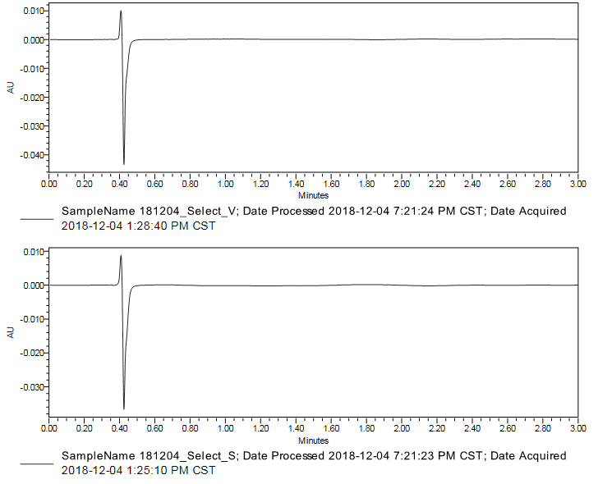
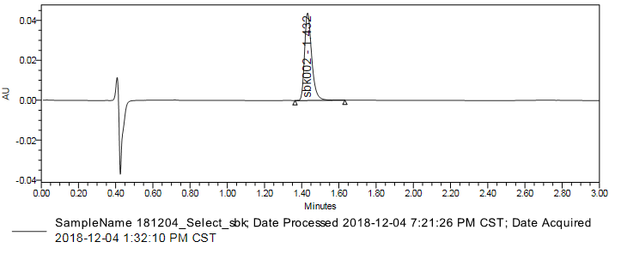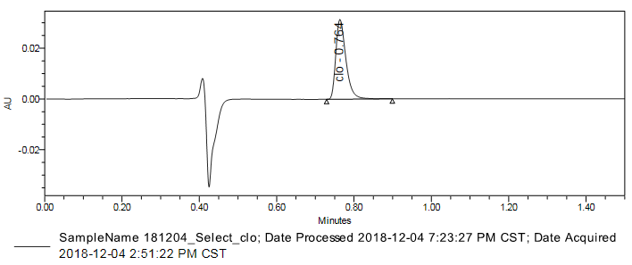
A：181204_Select_V
B：181204_Select_S
D：181204_Select_clo
C：181204_Select_sbk
Figure 1 Specificity
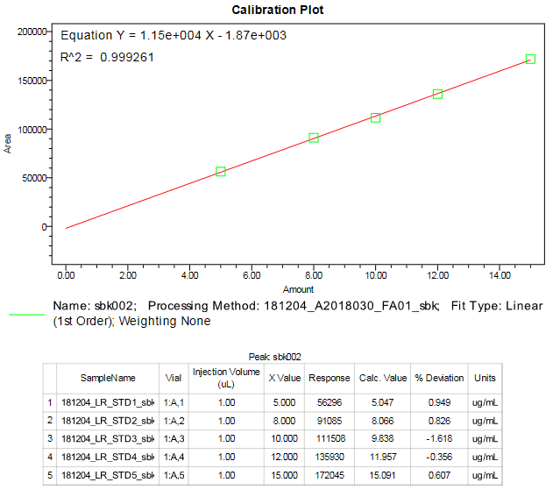
A：2018-12-04(sbk002)
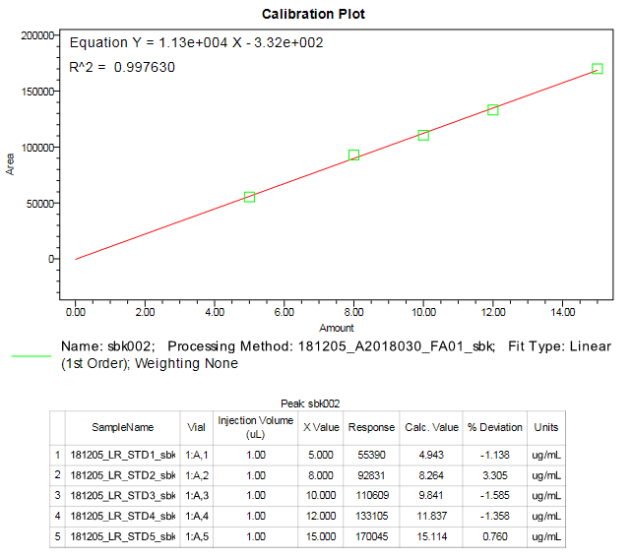
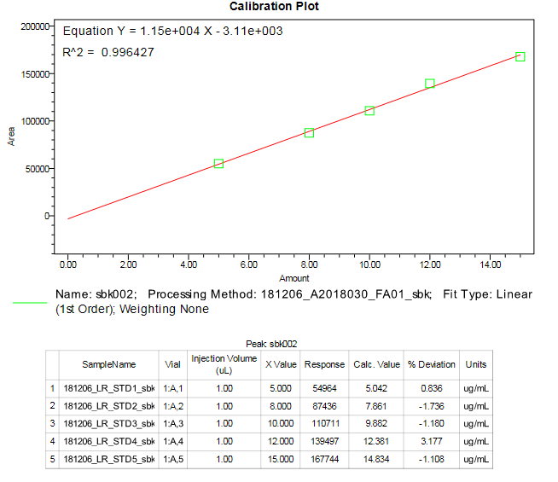
B：2018-12-05(sbk002)
B：2018-12-05(sbk)
C：2018-12-06(sbk002)
Figure 2-1 Standard Curve linear range (sbk002)
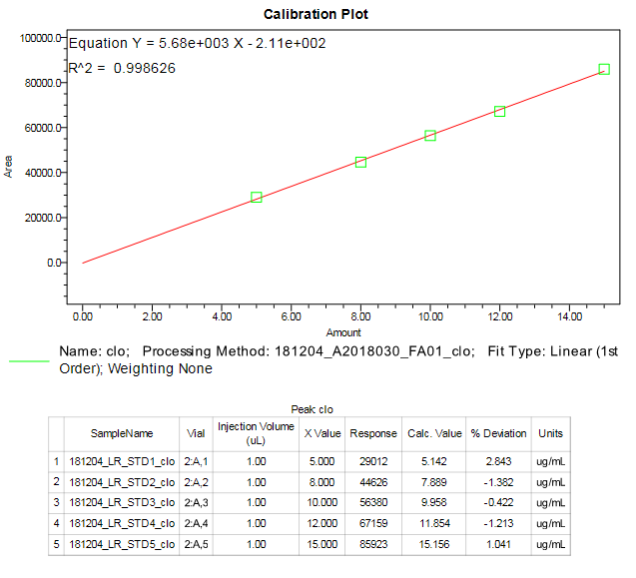
A：2018-12-04(clo)
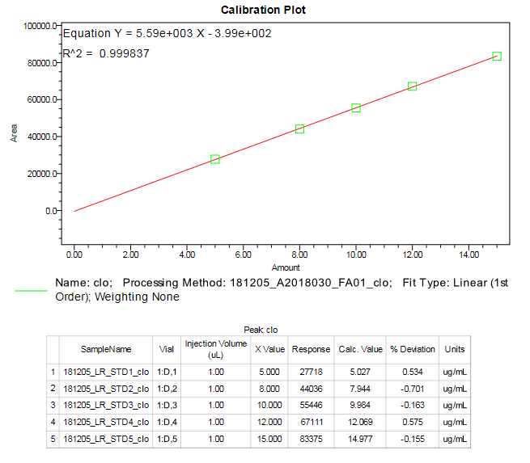
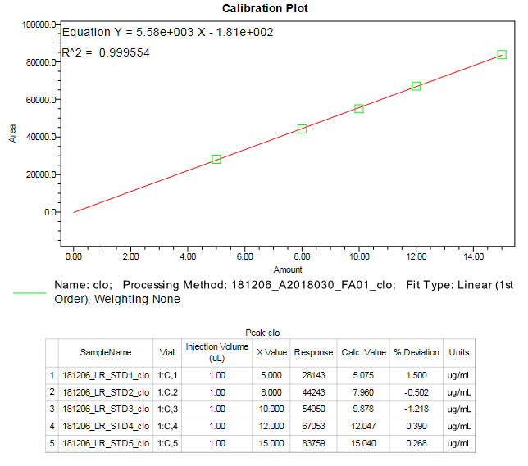
B：2018-12-05(clo)
B：2018-12-05(clo)
C：2018-12-06(clo)
Figure 2-2 Standard Curve linear range (clo)
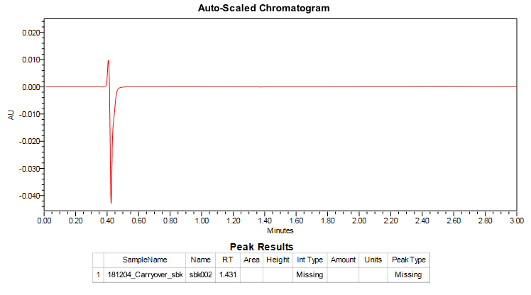
Figure 3-1 Carry-over (sbk002)

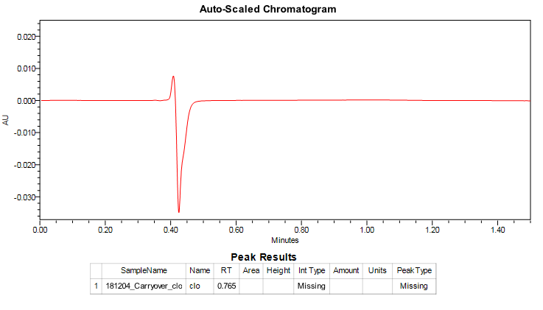
181204_Carryover_clo
Figure 3-2 Carry-over (clo)

